CIS 788 VLSI Computer Aided Design

Homework 1

Aifeng Yun

2014/10/8

# Test Case 1

Input: ~(A*B*(C+D+(E*F)))

Output:

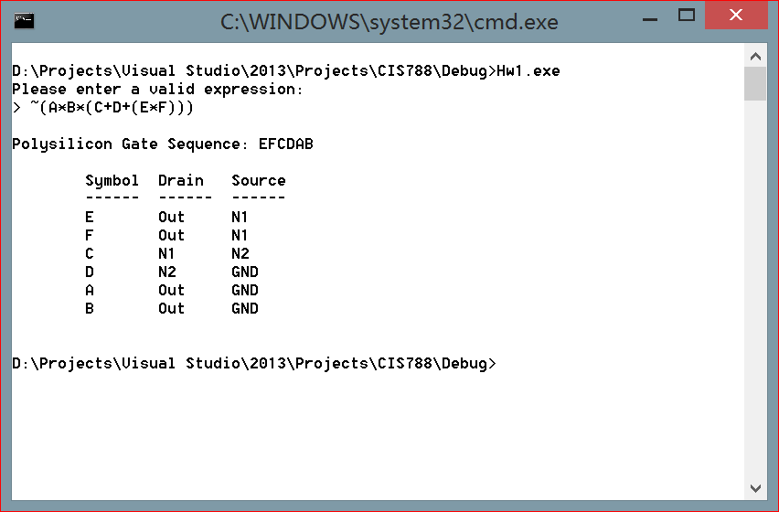

Netlist Graph:



# Test Case 2

Input: ~(K+((((A+B)*C*(D+E+F))+(G*H))*(I+J)))

Output:

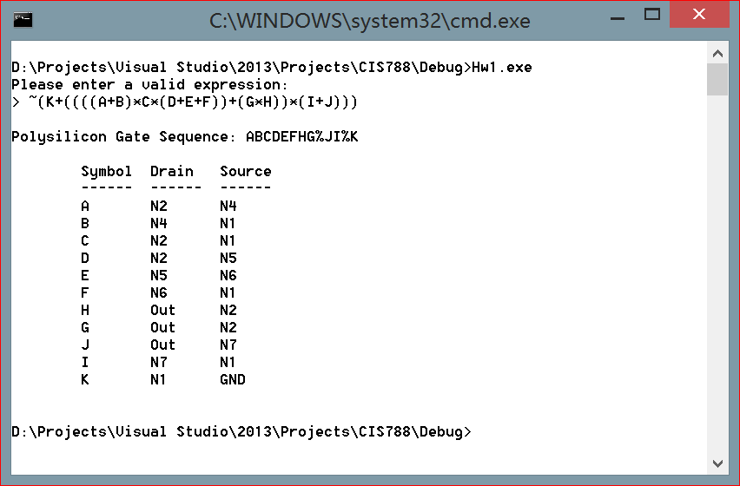

Netlist Graph:



# Test Case 3

Input: ~((((((G*(F+(A*B*C)))+D)*H)+I)*J)+E)

Output:

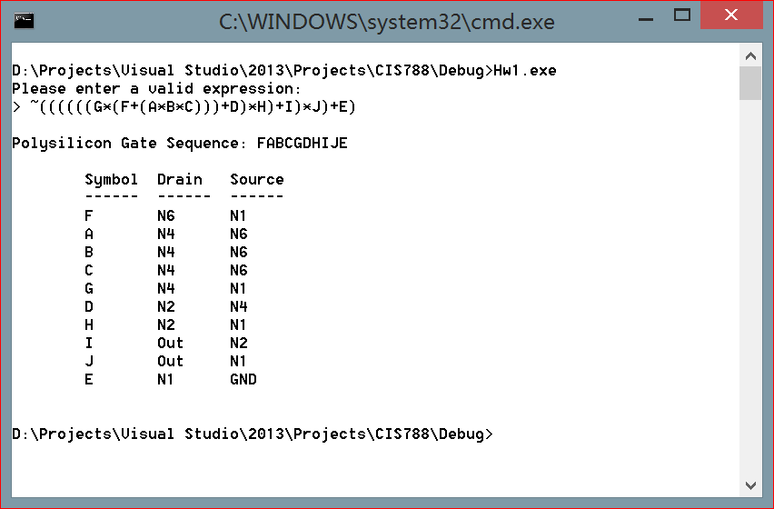

Netlist Graph:

# Test Case 4

Input: ~((J+K)*(F+((D*E)+C)+((G+H)*I))*A)

Output:

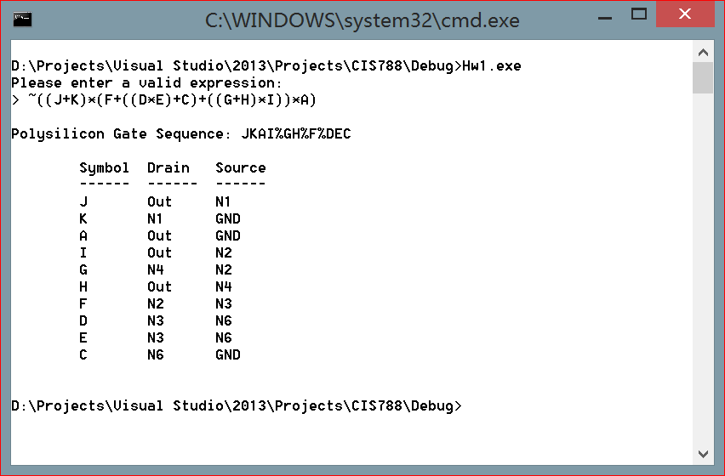

Netlist Graph: